**Replication stage- Harpreet singh**

In the replication stage, I have done the user acceptance test to see whether the program is running perfect but after running the main code it has been found that there are two common bugs in the given program. However, these bugs need to be fixed and are well illustrated below:

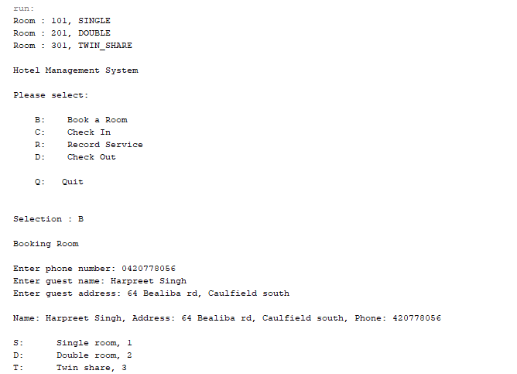

The above picture shows the booking process for the guest by input all details of the guest such as phone number, name, address and room type and it seems everything is alright with guest details as the code is running in a perfect way.

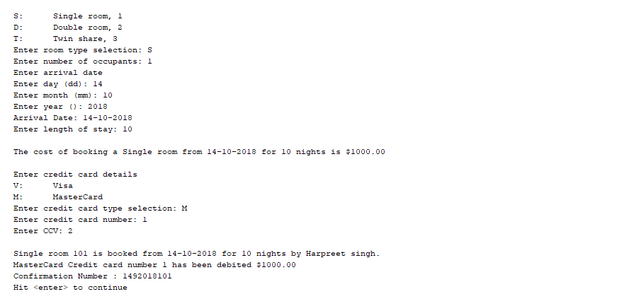

The above picture shows the further details of the guest for booking a room like length of stay, payment details and confirms the booking of the guest.

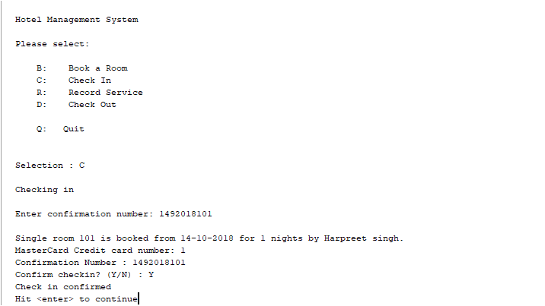

The screenshot above is the actual check-in of the guest. However, it asks for the confirmation number which was provided to the guest at the time of booking. After entering the confirmation, the status of room is changed to the checked-in status.

The Picture below shows the record for the service based on the room number. However, if the guest asks for the room service the charges will added to their room account and will be debited at time of checkout.

Moreover, in the given picture, the guest has used two room services which are marked with their price and shown below:

* Restaurant: $100
* Bar fridge: $120

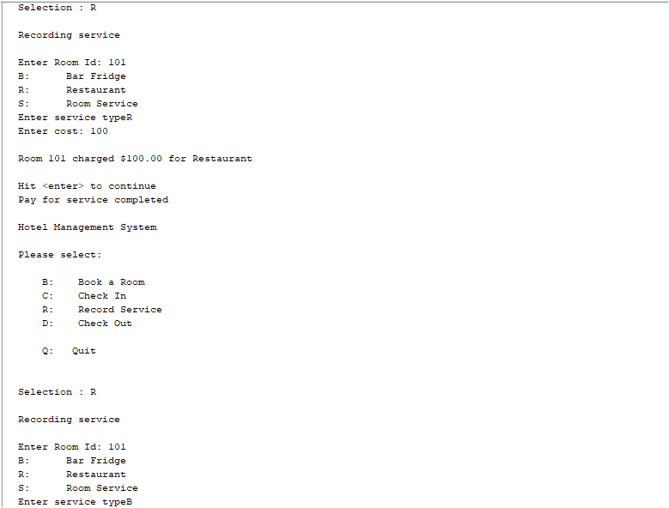

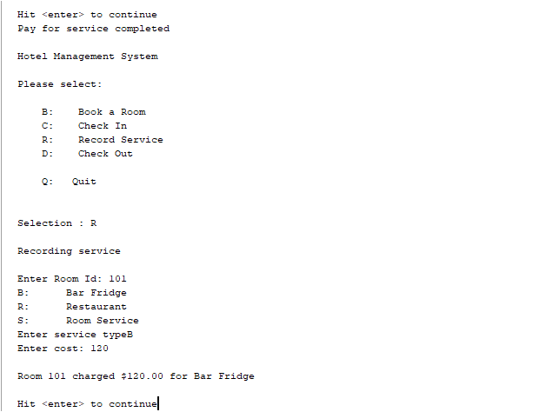

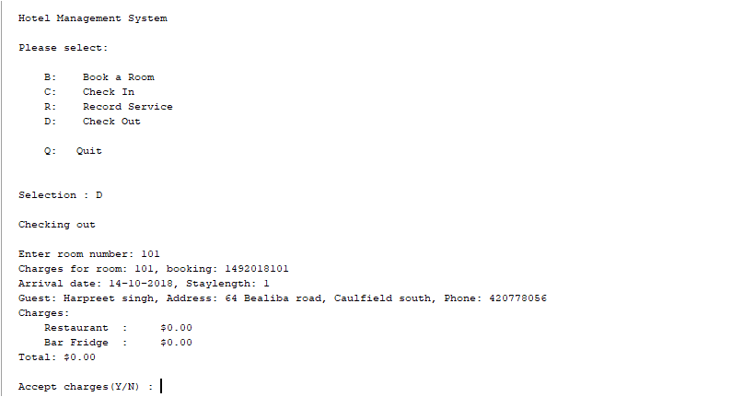

The above picture shows that guest has used the recorded service, but the system is not adding and displaying the outstanding amount $0.00, the services charges at the time of checkout.

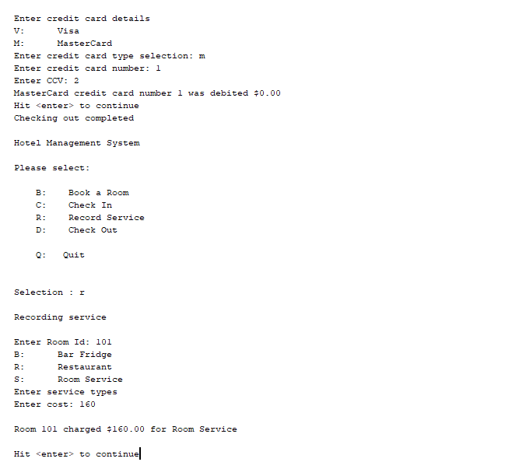

The above screenshot shows the checkout process of the guest and checkout status is completed as shown. Although, the guest has already been paid for the outstanding amounts while checkout, but still the system has changed the status to checkout and if we add any other record service it charged the customer the desired amount i.e. the status has not been changed and guest is still getting charged for the services which they haven’t used.